Introduction Page
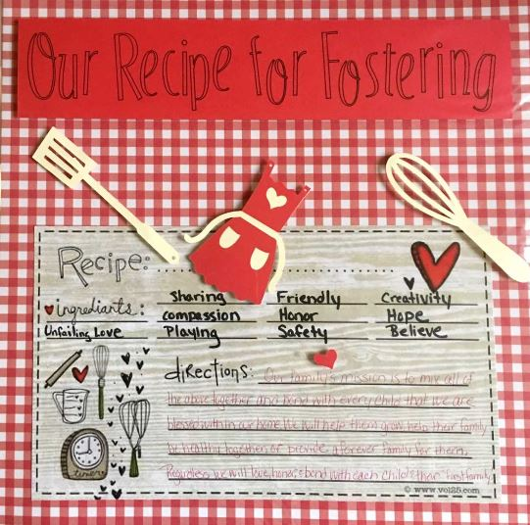
- Our Family Mission
  - Collectively (with all members of the family) write down the mission you would like to accomplish from becoming a foster family
  - Be sure to specific to your family and what your family has to offer
- Our Recipe for Fostering
  - Develop a “recipe card” just like you would for your favorite family dish. Include all parts (ingredients) and steps (directions) to carry out the recipe successfully.
- Our Story and Our Why
  - Write your family’s reason why and why decided to become a foster family.
  - Tell a story of why you became foster family, or be specific to an event that opened your heart to fostering.
Family Tree Page
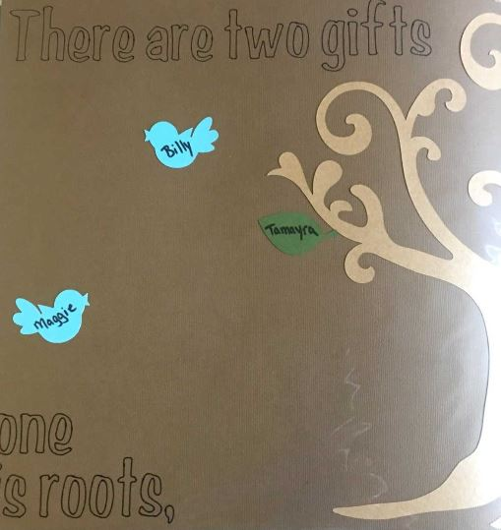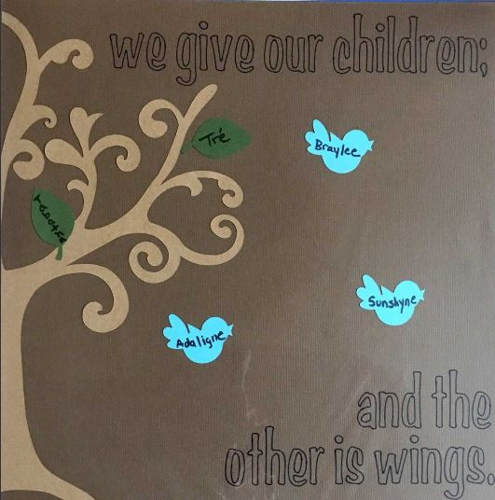
“There are two gifts we give our children; one is roots and the other is wings.”
- Develop a family tree that represents all members of your biological and adoptive family
  - Use leaves to represent the family members that have become rooted to your family biological and/or adoptive.
  - Add little birds to represent each foster child that has been reunified to their biological family.
What Fostering Means to Me?
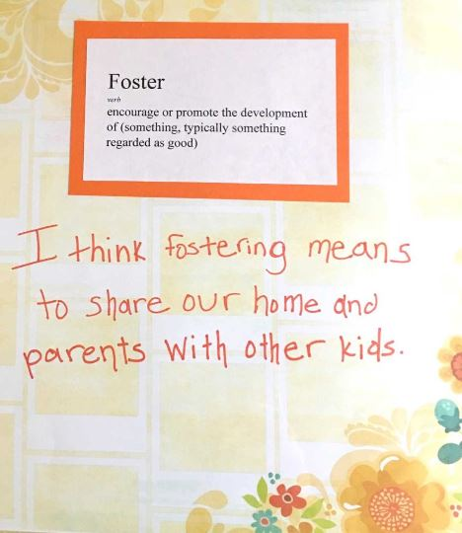
- This page is to be specific to each biological child, allow them a space to verbalize how they feel about fostering and what they expect is going to happen.
  - You could also include sections of this pages that represents different ages and how they felt about fostering at each age.
  - You can include the actual definition of foster to compare.

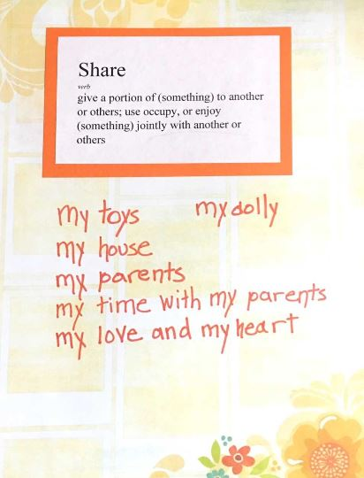
What Do I Have to Share?
- This page is again specific to each biological child, allow them a space to verbalize what they think has to be shared with a foster child(ren)
  - At first the items identified will probably be tangible items (ex. toys, my room, food), but as the biological child grow so will the page. The child will begin to identify many other things that is shared amongst the foster family (i.e. my mom, my dad, my time)

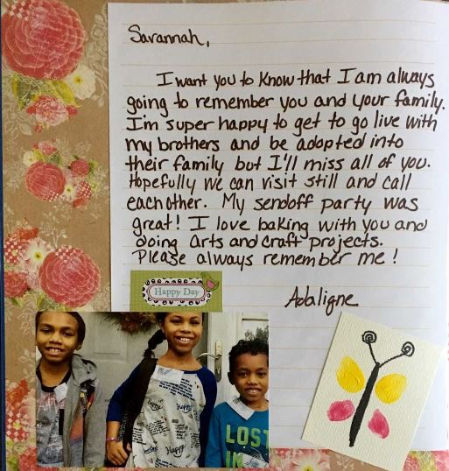
Foster Child Pages (two pages each)
- Create pages for each of the foster child that come into your home, this way the family or child can reflect upon the child for comfort
Page 1
- A letter from the foster child to your biological child
- A questionnaire completed by your biological child about the foster child (ex. My favorite memories of this child, I will remember this about this child)
- All of the foster child’s favorites (ex. Favorite thing to do with foster family)
Page 2
- Include pictures of the foster child with the foster family
- Include a hand print or foot print of the foster child
